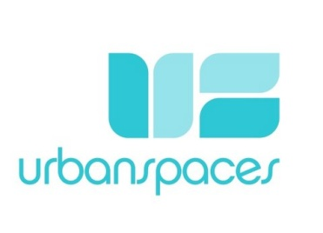
Retail Consulting Services
4787 Underwood Avenue
North Vancouver, BC, V7K 3B2
778 340 8585

RETAIL PROJECT SCOPE DESCRIPTION - To be outlined and to geared to your individual needs

OUR Retail Consulting Fees & Packages

Urban Spaces Design Co Inc. offers "By the Hour" or "By the Project" Pricing

3 Hr. min. = 225.00@HR = $675.00 + GST (2 hr Onsite Consultation + 1 hr. Written Recap sent by email

Note: 2 hrs can be rolled into either 10/20 hr pkg.

10 Hr. Pkg = $1750.00 + GST (Recommended for Space Planning & Adjacencies)

20 Hr. Pkg - 3000.00 + GST (Recommended for Complete Retail Evaluation of Space and Function ) Please note that this may take several packages. (Sheet of services attached)

* Note: Working, millwork detailed drawings are available at an extra cost of 125.00/hr. - Our Concept Interior Drawings are for reference use only.

After completion of this "20 hour pkg" you have the option to continue and "do it yourself" or if you would like more assistance simply sign up for another "hourly package"

Total estimated Job Cost (not incl. taxes) $_____

This is an estimate only, not a contract for services. It is based on our evaluation and does not include additional Interior Concept Design time, labour and/or material increases should unforeseen time or problems arise after the interior Client Agreement has been signed.
By checking the box beside the 3,10 or 20 hr PKG above and placing the $ amt.: signing and dating this form, we will consider this an agreement to go ahead with the Interior Project Scope as described above. We look forward to helping you create a space that represents you.

______________________________Name_______________________________Name ______/_______/_______MMDDYYYY

